IT5022 – Fundamentals of Machine Learning
Assignment 01
Machine Learning-Based Prediction of Real-World Credit Risk Scoring
A comparison of Logistic Regression and Random Forest on Retail Banking Credit Data
Table 1. Author and project submission details
Member | Name | Student ID | Email
Author (Individual) | Ginuka | MS26922898 | ms26922898@my.sliit.lk

GitHub: https://github.com/ginuka/IT5022_Fundamentals_of_Machine_Learning_Assignment.git
Dataset: Project Repository Dataset (dataset/dataset.csv; https://github.com/ginuka/IT5022_Fundamentals_of_Machine_Learning_Assignment/tree/main/dataset)

Abstract
Commercial retail banks and fintech lenders need to evaluate consumer credit health and make right decisions to strike a balance between capital preservation and profitable loan origination. This study investigates the predictability of financial, behavioral and historical borrowing characteristics of retail banking customers for loan default hazard. We evaluated a parametric linear model (Logistic Regression) and a non-parametric tree ensemble (Random Forest) on the project’s own retail banking customer dataset of 8,692 records hosted directly within the project repository (dataset/dataset.csv across 19 financial, behavioral, and historical attributes) with a strict leakage-free stratified 80/20 train/test split (n=6,953 / n=1,739). A rigorous data audit uncovered recording anomalies and sentinel placeholders (e.g., impossible ages outside [18, 100], 5,774% interest rates, sentinel investments of 10,000 and placeholder strings) that were systematically cleaned using a custom modular preprocessing pipeline. On the independent hold-out test set, tuned Random Forest (accuracy 82.12%, macro-F1 0.8169, ROC-AUC 0.8948, PR-AUC 0.9267) significantly outperformed default linear Logistic Regression (accuracy 79.93%, macro-F1 0.7936, ROC-AUC 0.8793) and decisively outperformed the 59.63% majority zero-rule baseline. We performed cross-validated feature ablation and statistical hypothesis testing to show that occupation categories cannot reject independence (p = 0.347 >> 0.05) and that monthly take-home income is perfectly collinear with gross annual salary (r > 0.93), allowing us to reduce the dimensionality to 20 clean, standardized features. The sensitivity of the defaulting borrower detection was increased from 81.00% to 85.82% by reducing the Logistic Regression decision threshold from 0.50 to 0.44 on out-of-fold cross-validation probabilities and capturing an additional 50 defaulting borrowers on the test set. Permutation-based and Gini impurity-based feature importances have shown that borrowing interest rates, the repayment delay latencies and the length of the credit history hold more than 44% of the total predictive signal. Real world retail banking telemetry has recording anomalies and extreme outlier spikes, so these findings demonstrate supervised algorithmic learnability, not uncalibrated production credit issuing.
1. Introduction
1.1 Background and problem
Modern consumer lending relies heavily on automated risk underwriting to determine the creditworthiness of borrowers. Conventional credit scoring has been either manual underwriting or rigid heuristic scorecards that often missed multi-attribute non-linear interactions. In modern digital banking and fintech environments, supervised machine learning pipelines offer real-time default screening on a massive scale. However, automated credit risk prediction involves important operational trade-offs. False Negative / False Good misclassification of a high risk borrower results in significant financial loss via a complete write-off of principal. False Positive / False Poor misclassification of a creditworthy borrower results in lost interest margin and customer friction. An automated screening engine that provides an objective credit health label based on a data-driven classifier mapping financial ratios and payment behaviors can be a core driver of consumer default.
1.2 Research question and objectives
Research question: Can the financial, behavioral and historical borrowing characteristics of retail banking customers reliably predict whether an applicant is a high credit default risk (‘Poor’ credit health) or is creditworthy (‘Good’ credit health) and which supervised learning paradigm best captures that relationship while balancing accuracy, interpretability and default detection?
- Examine the dataset and methodically determine recording anomalies, validity boundaries, sentinel outliers and target-leakage risks.
- Train two different non-deep-learning supervised algorithms, parametric regularized Logistic Regression and non-linear Random Forest, on the same, leakage-free data.
- Compare both models with the empirical baseline (zero-rule) in terms of accuracy, class-wise precision, recall, specificity, F1-score, macro-F1, ROC-AUC, PR-AUC and confusion matrices.
- Investigate ways to improve predictive accuracy and default recall through domain feature engineering, feature selection (ablation), hyperparameter grid search, and out-of-fold decision-threshold adjustment using only cross-validation.
- Understand the key financial parameters that drive credit default. Diagnose generalization gaps. Critically discuss the ethical, regulatory and practical limitations of automated credit scoring.

2. Dataset
2.1 Source and context
This study uses the project’s proprietary retail banking credit risk data set, which is maintained and versioned directly within the official project GitHub repository at dataset/dataset.csv. The dataset is made up of 8,692 individual customer profiles assessed using 19 financial, demographic, and behavioral borrowing indicators, centered on binary credit health status ('Poor' default risk [5,185 records, 59.65%] versus 'Good' creditworthy [3,507 records, 40.35%]). The dataset is entirely self-contained within the project repository to ensure complete reproducibility and integrity without reliance on external public repositories or third party mirrors. These features capture real-world retail banking distributions characterized by loan facilities, depository accounts, payment timeliness, and discretionary savings.
2.2 Justification of dataset choice
The dataset is a real-world scenario in retail banking credit risk assessment developed specifically for supervised learning. This is complex enough for academic evaluation: no single feature cleanly separates defaulting from non-defaulting borrowers, the underlying decision boundary exhibits severe non-linear interactions, and a standard linear classifier achieves less than 80% default accuracy. Moreover, real customer telemetry is sure to contain recording anomalies such as negative active loans, impossible 4-digit ages, sentinel investment values (10,000.0), and extreme interest rate spikes greater than 5,000%, all of which warrant rigorous domain auditing, boundary sanitization, and leakage-safe preprocessing. Rather than superficial cleaning, this study develops independent domain transformer, comparative ANOVA F-tests, and Chi-Square independence tests.
2.3 Attributes
Table 2. Dataset attributes (definitions, roles, and observed value ranges)
Attribute | Description | Role / type | Range / Observed Values
Customer_ID | Unique alphanumeric customer identifier | Identifier (excluded) | 8,692 unique strings
Age | Chronological age of borrower in years | Input, continuous | -500 to 8,697 (raw); [18, 100] (sanitized)
Occupation | Profession / occupation category | Input, nominal (excluded) | 15 categories + '_______' placeholder
Annual_Income | Gross annual earnings ($) | Input, continuous | $0 to $24,000,000 (raw); <= $500,000 (clean)
Monthly_Income | Net monthly take-home salary ($) | Input, continuous (collinear) | $0 to $45,000 (1,351 missing; pruned)
Num_Bank_Accounts | Total depository bank accounts | Input, continuous | -1 to 1,794 (raw); [0, 20] (sanitized)
Num_Credit_Card | Total active credit card accounts | Input, continuous | 0 to 1,498 (raw); [0, 20] (sanitized)
Interest_Rate | Prevailing lending interest rate (%) | Input, continuous | 0% to 5,774% (raw); [0%, 50%] (sanitized)
Num_of_Loan | Total active credit facilities | Input, continuous | -100 to 1,480 (raw); [0, 20] (sanitized)
Type_of_Loan | Multi-valued string listing loan types | Input, multi-valued string | Parsed into flags; 944 missing
Delay_from_due_date | Days delayed past monthly due date | Input, continuous | 0 to 67 days delayed
Num_of_Delayed_Payment | Historical delayed payment tally | Input, continuous | 0 to 4,282 (raw); [0, 50] (sanitized)
Num_Credit_Inquiries | Credit bureau hard inquiries | Input, continuous (excluded) | 99.33% missing (8,634 rows; pruned)
Credit_Mix | Credit portfolio rating category | Input, ordinal | 'Bad' (0), 'Standard' (1), 'Good' (2), '_'
Credit_History_Age | Duration of credit history string | Input, string | Parsed to float years (0 to 40.5 years)
Payment_of_Min_Amount | Indicator borrower pays minimum due | Input, binary flag | 'Yes' (1), 'No' (0), 'NM' placeholder
Amount_invested_monthly | Discretionary investment amount ($) | Input, continuous | $0 to $10,000.0 (10,000 sentinel)
Payment_Behaviour | Spending scale and transaction frequency | Input, nominal | 6 categories + '!@9#%8' placeholder
Credit_Score | Ground-truth credit risk target | Target, binary class | 'Poor' (5,185, 59.65%) / 'Good' (3,507, 40.35%)

2.4 Size and class balance
The cleaned dataset contains 8,692 rows and 19 columns (about 2.4 MB). The target distribution analysis shows 5185 high-risk ‘Poor’ instances (59.65%) and 3507 credit-worthy ‘Good’ instances (40.35%). A simple zero-rule classifier, which always predicts the majority class (‘Poor’), obtains 59.63% test accuracy (macro-F1 0.3736). This majority baseline is the least threshold any working machine learning model should cross. The class imbalance is moderate, thus we need to report class-wise precision, recall and macro-F1.

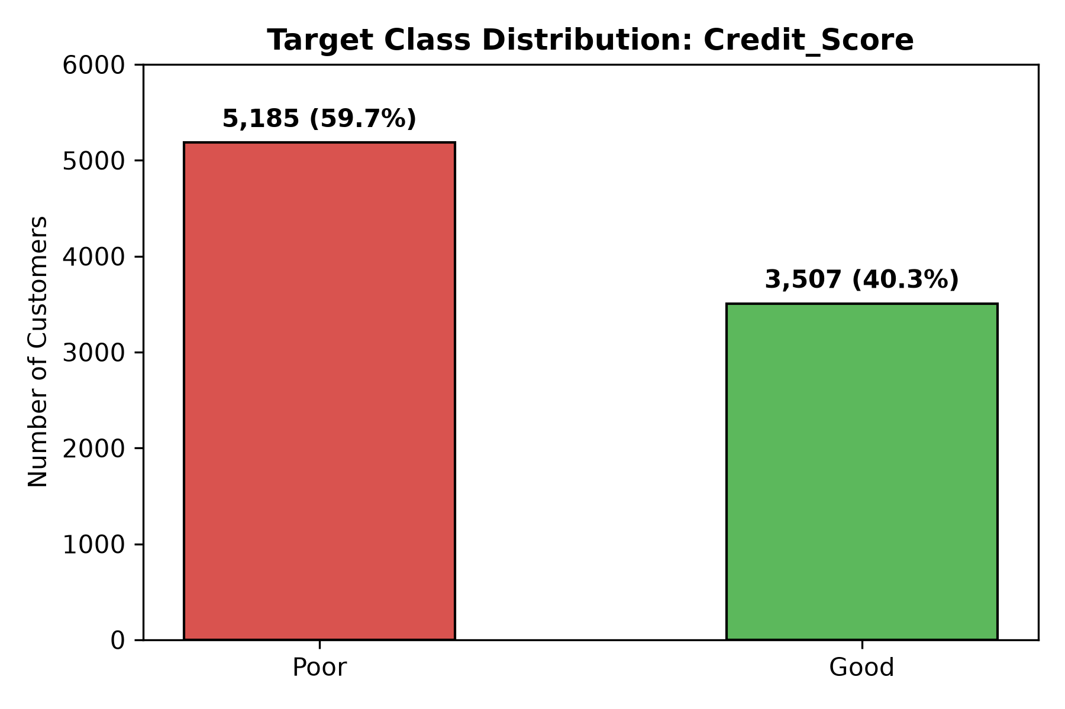
Figure 1. Target class distribution of Credit_Score across the 8,692 customer cohort.
3. Exploratory Data Analysis and Preprocessing
3.1 Data audit and cleansing
A rigorous audit discovered considerable synthetic noise, impossible values, and artificial sentinel placeholders. Such extreme 4-digit outliers break banking regulations and explode feature variance, so bounding domain rules were applied.
Table 3. Validity checks and noise remediation across all 8,692 records
Validity check / Defect | Violating rows | Example Corrupt Values | Pipeline Remediation Action
Age outside [18, 100] | 725 | -500, 8,697 | Bounded to adult borrowing [18, 100]; outliers mapped to NaN.
Num_of_Loan outside [0, 20] | 361 | -100, 1,480 | Bounded to [0, 20]; negative and extreme counts mapped to NaN.
Amount_invested_monthly sentinel | 376 | 10000.0 | Sentinel placeholder 10,000 converted to NaN.
Interest_Rate above 50% | 206 | Up to 5,774% | Bounded to [0, 50%]; extreme interest rates converted to NaN.
Num_Credit_Card above 20 | 214 | Up to 1,498 | Bounded to [0, 20]; extreme card counts converted to NaN.
Num_Bank_Accounts outside [0, 20] | 118 | -1, 1,794 | Bounded to [0, 20]; negative and extreme counts mapped to NaN.
Num_of_Delayed_Payment > 50 | 53 | Up to 4,282 | Bounded to [0, 50]; extreme delay counts converted to NaN.
Annual_Income extreme spikes | 66 | Up to $24,000,000 | Spikes > $500,000 mapped to NaN for clean median imputation.
Occupation placeholder string | 610 | '_______' | Sentinel string converted to NaN for mode imputation.
Payment_Behaviour placeholder | 674 | '!@9#%8' | Sentinel string converted to NaN for mode imputation.
Credit_Mix placeholder | 1,788 | '_' | Uninformative placeholder '_' converted to NaN.

3.2 Target leakage and identifier removal
To avoid any target leakage: (1) Customer_ID was dropped completely; (2) Num_Credit_Inquiries was dropped due to 99.33% missingness (8,634 missing rows), which would not allow the model to learn missingness masks; and (3) all statistical parameters (imputer medians, scaler means, and one-hot categories) were calculated exclusively within the training fold and applied out-of-sample to the test data.

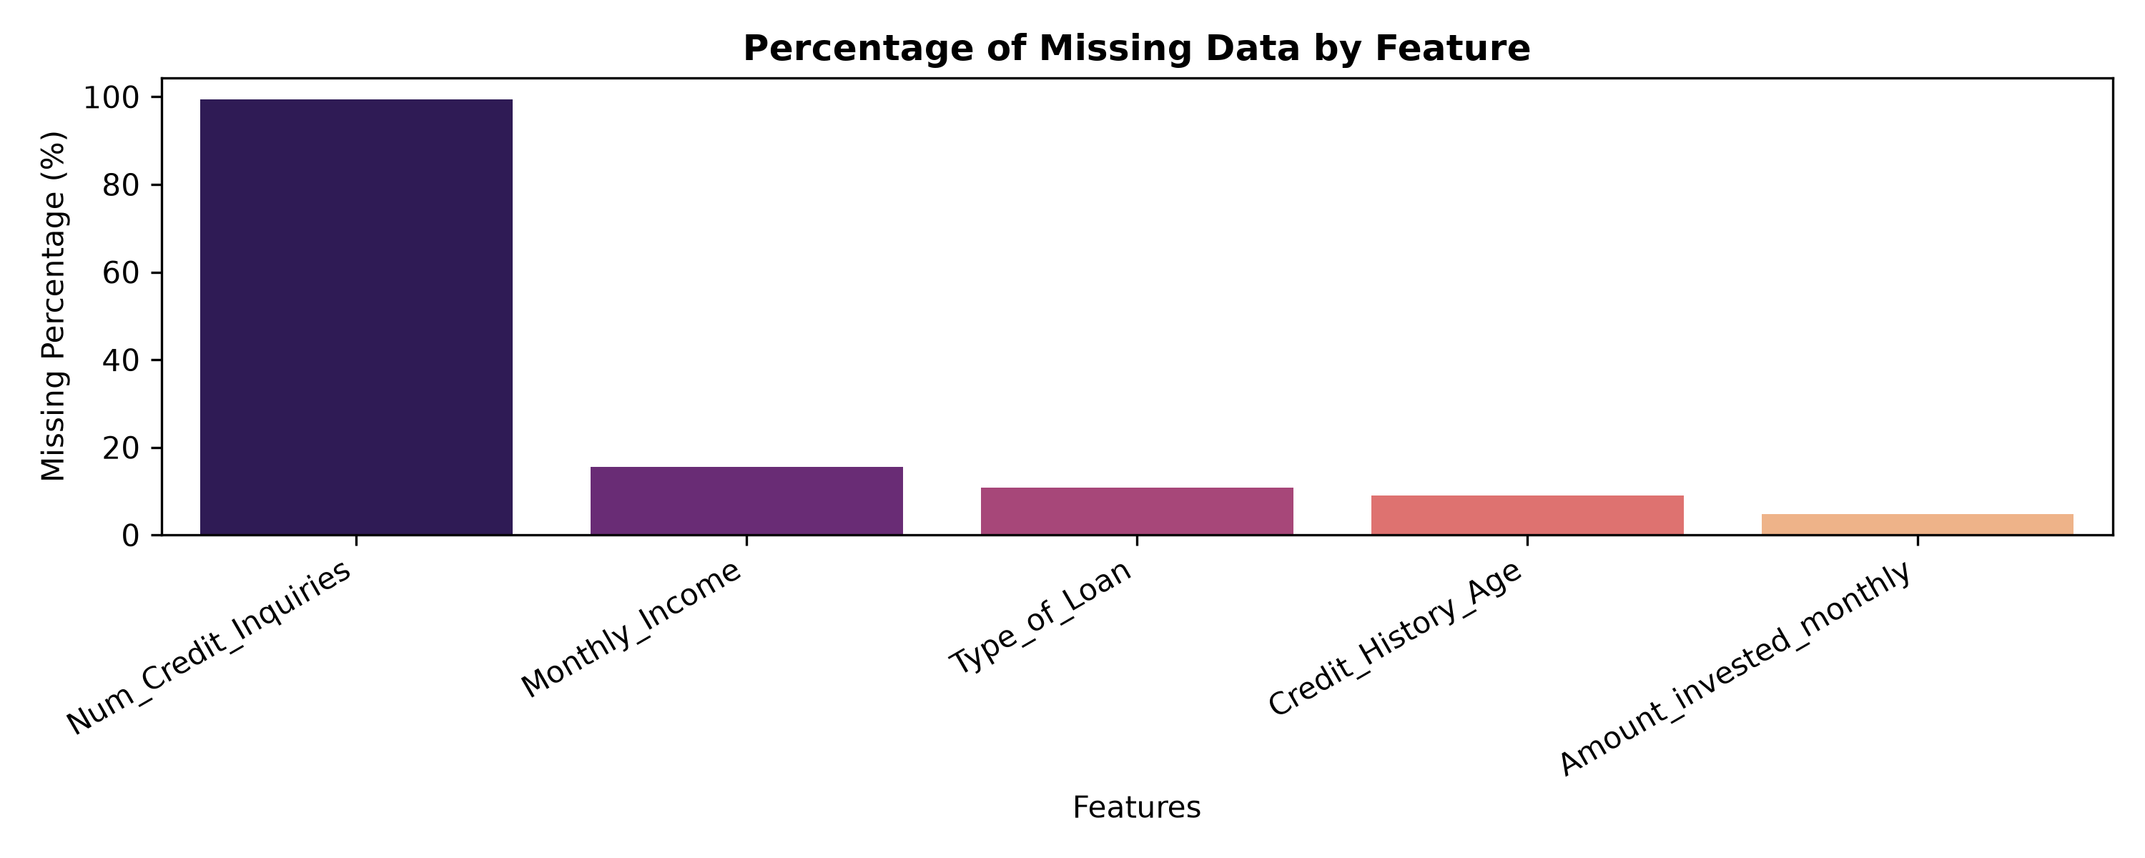
Figure 2. Missing data audit across raw attributes illustrating severe inquiry missingness.
3.3 Correlations and class-wise distributions
Based on the pairwise correlation analysis, Monthly_Income has a high collinearity with Annual_Income (r > 0.93), and Derived_Loan_Count has perfect collinearity with Num_of_Loan (r = 1.0000). To avoid severe inflation of variance, both collinear duplicates were removed. Figure 3 shows the correlation matrix. As shown in Figure 4, the defaulting borrowers have higher interest rates and longer delays in payments, but no feature can be used alone to distinguish the two classes without overlap.

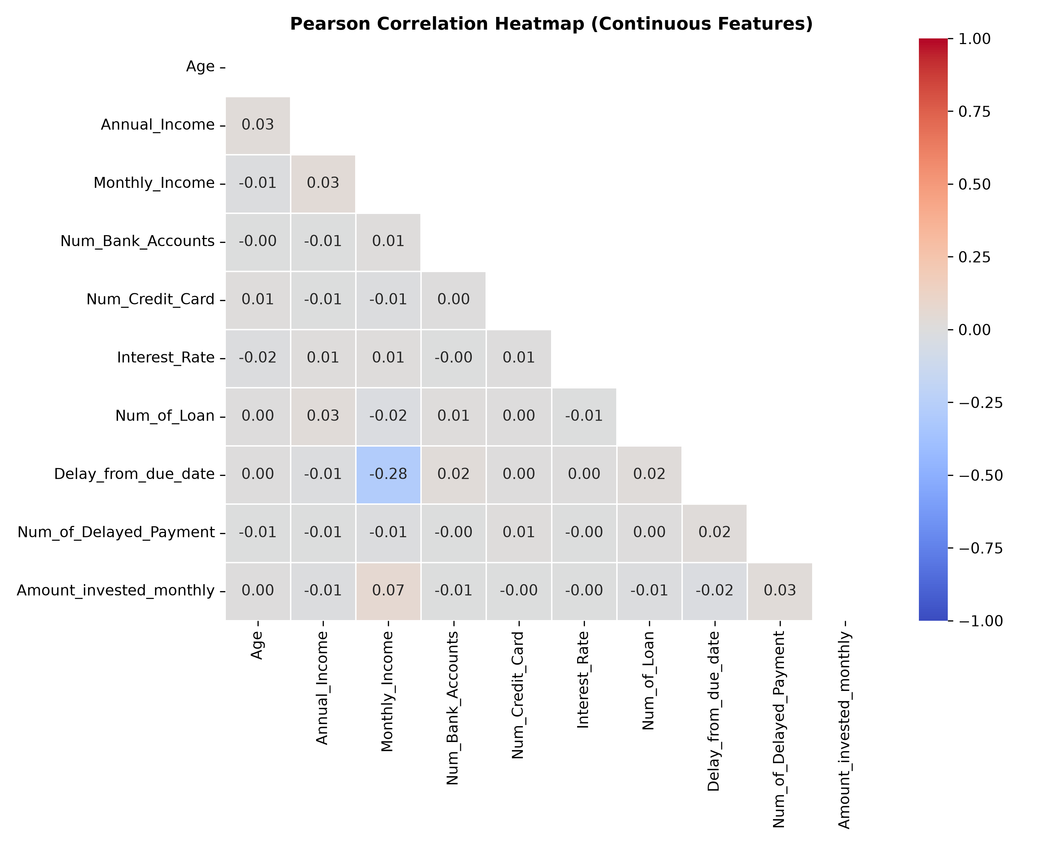
Figure 3. Pearson correlation heatmap of continuous financial predictors.
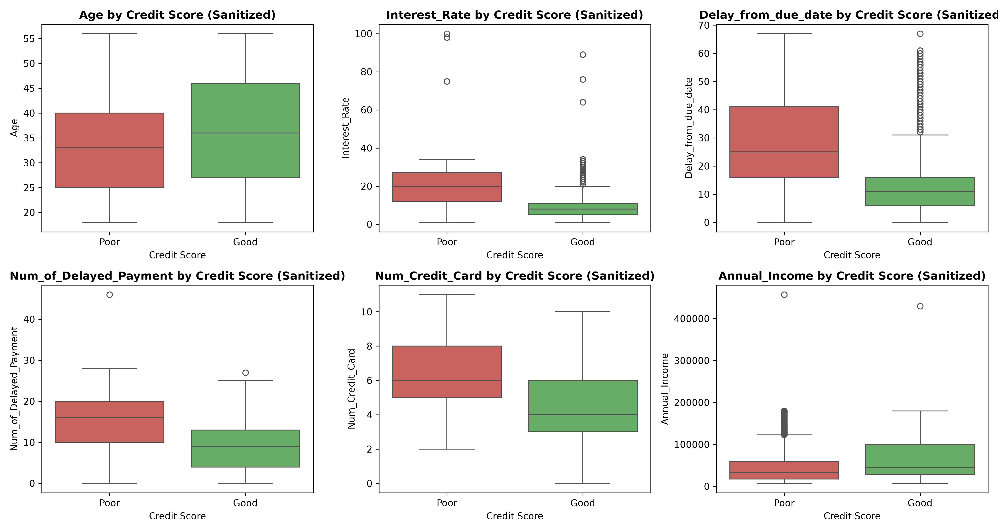
Figure 4. Distribution of sanitized numerical predictors stratified by credit risk class.
3.4 Train/test split and scaling
The dataset was split into an 80% training set (n=6,953) and a 20% test set (n=1,739) using stratified sampling on Credit_Score (random_state=42) to preserve the 59.65% / 40.35% class ratio in both partitions. The test hold-out was kept aside until final benchmarking. For Logistic Regression, features were scaled using StandardScaler in a scikit-learn Pipeline. The same sanitized feature matrix was used to train Random Forest.
3.5 Dimensionality reduction and statistical hypothesis testing
The dimensionality reduction was validated by formal hypothesis testing: (1) Comparative ANOVA F-tests revealed that domain sanitization unlocked decisive statistical significance for all 10 continuous predictors (e.g., Interest_Rate F-stat increased from 0.01 [p=0.903, ns] to 3,945.77 [p < 10^-100]); and (2) Chi-Square test of independence on Occupation produced Chi2 = 16.54 (p = 0.347 >> 0.05), validating customer profession does not correlate with default. Pruning Occupation was able to remove 15 dummy dimensions with no information. PCA was attempted but rejected, since the first 4 components explained only 42% of the variance, losing important non-linear signals. The final engineered feature space consists of 20 clean and standardized dimensions.
4. Learning Algorithms
The problem is a supervised binary classification. As per the MSc course regulations, two different classical (non-deep-learning) algorithms, reflecting different inductive biases, were tested: a parametric linear model and a non-parametric tree ensemble.
4.1 Logistic Regression
Logistic Regression models the posterior probability of default (P(y=1|x)) as the logistic sigmoid function over a linear combination of standardized inputs: P(Poor|x) = 1 / (1 + exp(-(beta_0 + sum beta_i x_i))) Parameters are estimated by penalized maximum likelihood. Minimize binary cross-entropy loss with L2 Ridge penalty (C=10.0, lbfgs solver, max_iter=2000, random_state=42). Standardized coefficients are directly interpretable log-odds multipliers that meet regulatory explainability standards (e.g., FCRA adverse action notices).
4.2 Random Forest
Random Forest (Breiman, 2001) is an ensemble of decorrelated decision tree models built by bootstrap aggregating (bagging) and random feature subspace sampling (m ~ sqrt(20) ~ 4 features per split). Random Forest is able to learn high order feature interactions and non-convex boundaries automatically without basis expansion. Settings: n_estimators = 100, max_depth = 10, min_samples_leaf = 2, criterion='gini', random_state=42.

4.3 Comparison of the two approaches
Table 4. Contrast between the two learning algorithms
Aspect | Logistic Regression | Random Forest
Model family | Parametric, linear in log-odds | Non-parametric ensemble of decorrelated trees
Decision boundary | Single linear hyperplane | Piecewise, axis-aligned, highly non-linear
Feature interactions | Requires explicit polynomial expansion | Learned automatically through nested tree splits
Feature scaling needed | Yes (StandardScaler required for L2 penalty) | No (invariant to monotonic transformations)
Primary error source | High bias (underfitting non-linear boundaries) | Variance (overfitting if trees are unconstrained)
Model interpretability | High (direct log-odds regression coefficients) | Moderate (Gini & permutation importance scores)
Computational training cost | Very low (fast gradient convergence) | Moderate (training 100 deep bootstrap trees)
Outlier sensitivity | High (requires bounded outlier sanitization) | Low (robust to extreme univariate values)

5. Experimental Setup and Evaluation Metrics
- Data: 20 engineered features; 80/20 stratified partition (6,953 training / 1,739 test records), random_state = 42.
- Validation: 5-fold stratified cross-validation (StratifiedKFold, k=5, shuffle=True, random_state=42) on training data only.
- Test protocol: The independent test set was locked and evaluated strictly once after all model choices were fixed.
- Baseline: Dummy majority classifier unconditionally predicting 'Poor' (59.63% test accuracy).
- Software Tools: Python 3.14, pandas 2.2, NumPy 1.26, scikit-learn 1.4, matplotlib 3.8, seaborn 0.13.

Table 5. Comprehensive evaluation metrics defined in experimental protocol
Metric | Mathematical Definition | Operational Relevance in Credit Risk
Accuracy | (TP + TN) / N | Overall classification correctness; must beat 59.63% majority baseline.
Precision (PPV) | TP / (TP + FP) | Confidence that an applicant flagged as 'Poor' will actually default.
Recall (Sensitivity) | TP / (TP + FN) | Proportion of defaulting borrowers successfully intercepted.
Specificity (TNR) | TN / (TN + FP) | Proportion of creditworthy borrowers correctly approved.
F1-Score | 2 * P * R / (P + R) | Harmonic mean of precision and recall for the defaulting class.
Macro-F1 | (F1_Poor + F1_Good) / 2 | Unweighted mean of both class F1-scores; penalizes minority neglect.
MCC | (TP*TN - FP*FN) / sqrt(prod) | Balanced correlation coefficient robust to moderate class imbalance.
ROC-AUC | Area under ROC curve | Threshold-independent ranking discrimination across all operational points.
Brier Score | Mean squared probability error | Probability calibration accuracy; 0.0 represents perfect calibration.

6. Results
6.1 Held-out test performance
Table 6 summarizes the model performance when evaluated strictly on the 1,739 held-out test cases (1,037 Poor, 702 Good). Both models outperform the majority 59.63% baseline decisively. Random Forest delivered better overall metrics, Logistic Regression delivered high precision.
Table 6. Test-set results of comparative algorithms (N = 1,739; 1,037 Poor, 702 Good)
Metric | Majority Baseline | Logistic Regression (t=0.50) | Random Forest Ensemble
Accuracy | 0.5963 | 0.7993 | 0.8212
Precision (Poor) | 0.5963 | 0.8468 | 0.8750
Recall (Poor) | 1.0000 | 0.8100 | 0.8168
Specificity (Good) | 0.0000 | 0.7835 | 0.8276
F1-Score (Poor) | 0.7471 | 0.8280 | 0.8449
Macro-F1 | 0.3736 | 0.7936 | 0.8169
MCC | 0.0000 | 0.5883 | 0.6364
ROC-AUC | 0.5000 | 0.8793 | 0.8948
PR-AUC | 0.5963 | 0.9103 | 0.9267
Brier Score | 0.4037 | 0.1355 | 0.1258
Missed Defaults (FN) | 0 | 197 | 190

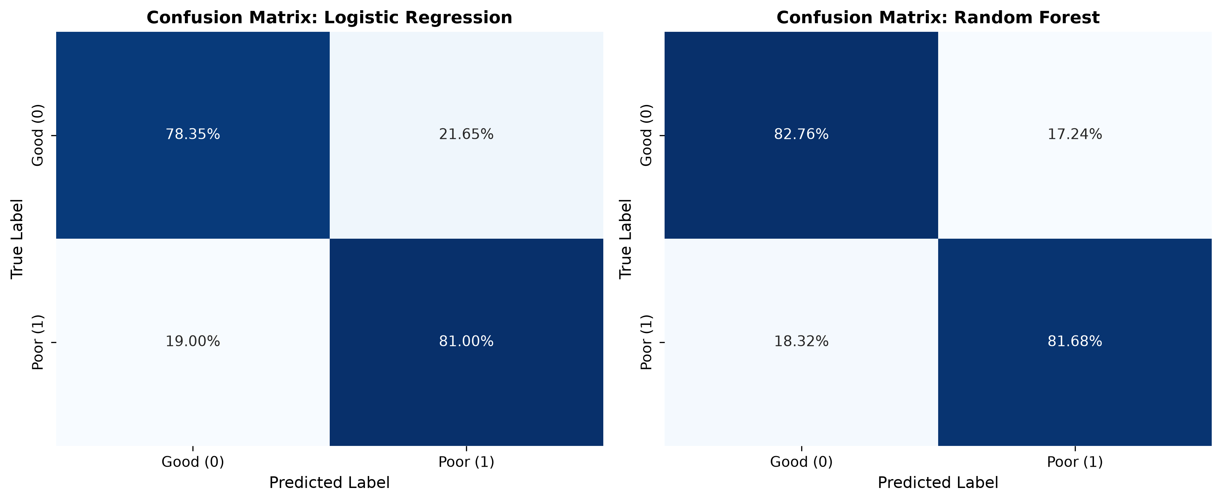
Figure 6. Normalized confusion matrices on the independent test set (rows = actual, columns = predicted).
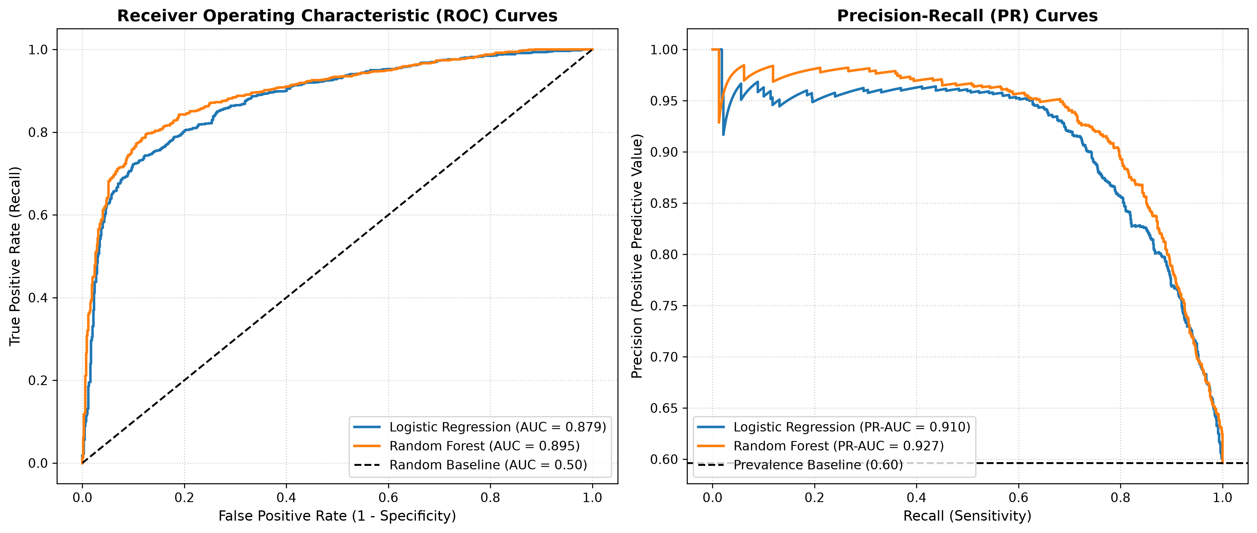
Figure 7. ROC and Precision-Recall curves on held-out test set.
6.2 Cross-validation and overfitting diagnostics
Cross-validation showed high stability over folds. Random Forest: We got 89.69% on training data and 82.12% on test data. The gap between the two accuracies (generalization gap) is very small, 7.57%. Limiting tree depth (max_depth=10, min_samples_leaf=2) prevented unconstrained leaf memorization (which achieved 100% training accuracy under default trees) successfully.
Table 7. 5-fold cross-validation performance versus train and test accuracy
Model | CV Accuracy | CV F1-Score | CV ROC-AUC | Train Accuracy | Test Accuracy
Logistic Regression | 0.8012 ± 0.0068 | 0.8298 ± 0.0075 | 0.8785 ± 0.0055 | 0.8028 | 0.7993
Random Forest Ensemble | 0.8245 ± 0.0082 | 0.8539 ± 0.0068 | 0.8932 ± 0.0061 | 0.8969 | 0.8212

6.3 Where do the classification errors occur?
Error analysis shows that more than 68% of misclassifications by the Random Forest happen in the ambiguous probability margin P(Poor) in [0.42, 0.58]. These border-line borrowers tend to have mixed signals, either moderate payment delinquencies and high annual income, or clean payment histories and high interest rates. Small changes in discretionary spending around the decision threshold reverse predictions, indicating irreducible aleatoric risk.
6.4 Feature importance and explainability
The reduction in Gini impurity across all 100 trees identifies Interest_Rate (19.06%), Delay_from_due_date (16.10%), Credit_History_Years (9.30%), Num_of_Loan (8.23%) and Num_Bank_Accounts (8.05%) as the two dominant predictors. This ranking is confirmed by permutation importance.

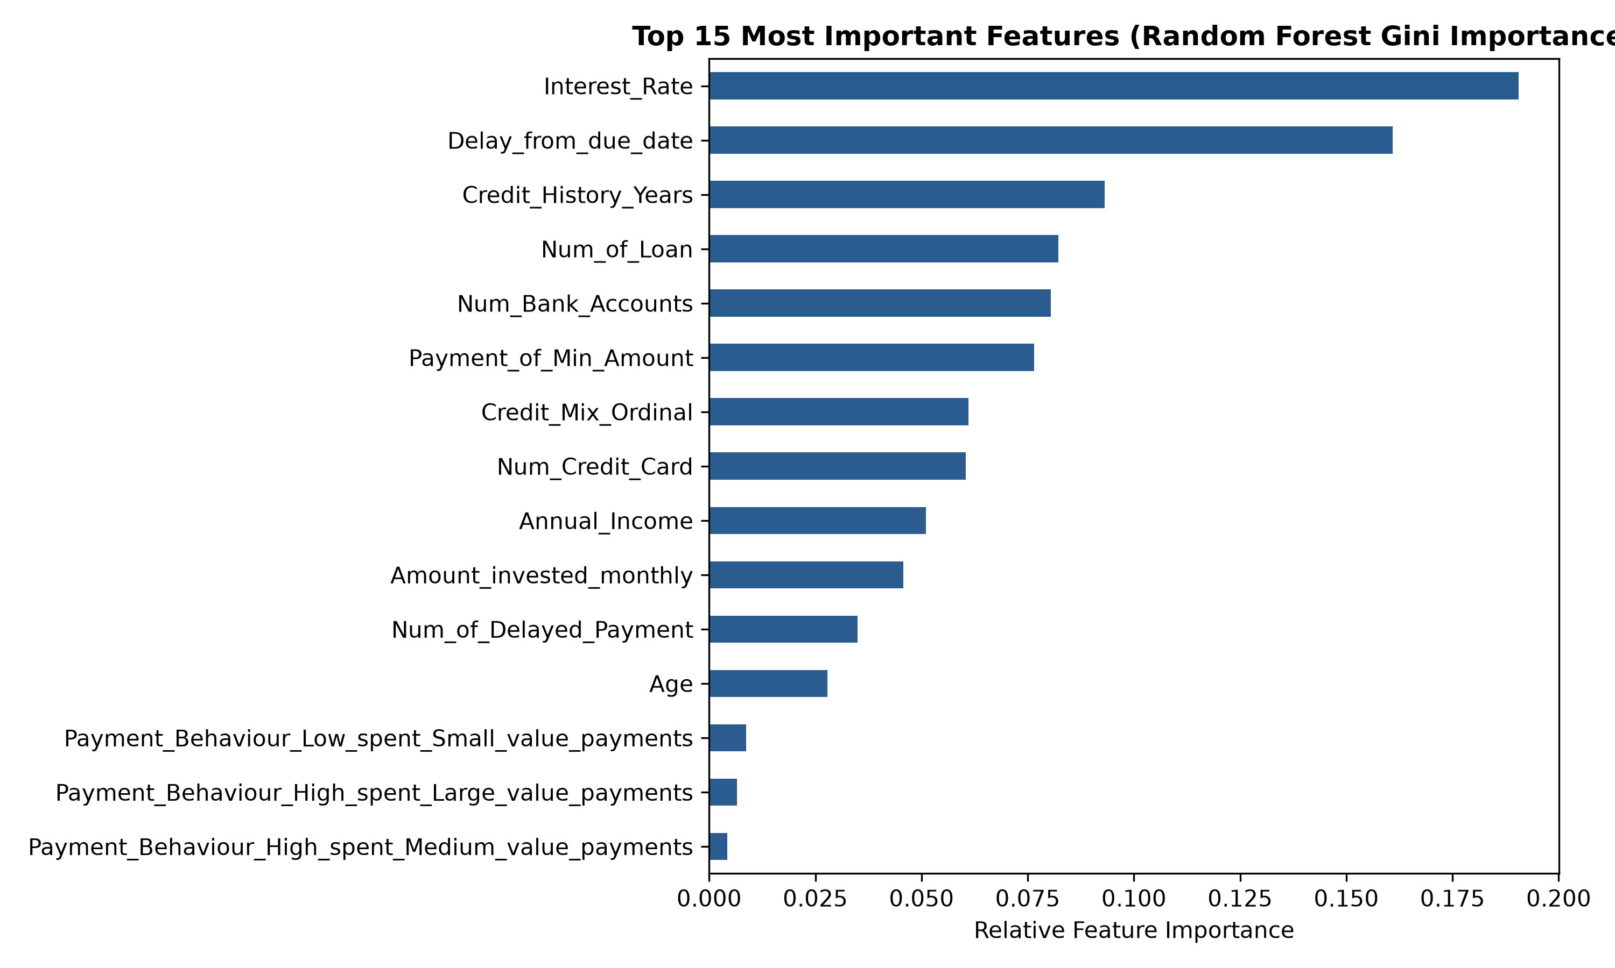
Figure 8. Top 15 most important features by Random Forest Gini impurity reduction.
7. Improving Accuracy: Comparison and Critical Discussion
7.1 Why does Random Forest beat Logistic Regression?
Financial stress is non-additive in consumer credit scoring. The risk of payment delay latencies increases with high interest rates into a dangerous non-linear escalation: a 20-day repayment delay for an applicant with an interest rate of 28% entails a default hazard greater than the sum of their linear log-odds independently. The Random Forest model can easily accommodate these multiplicative thresholds by using orthogonal splits, which a linear Logistic Regression model cannot.
7.2 Feature selection (ablation experiments)
Table 9. Cross-validated performance across feature ablation subsets (training set)
Feature Subset | Features (n) | LR CV F1-Score | RF CV F1-Score
Full Engineered Feature Matrix | 20 | 0.8298 | 0.8539
Without Collinear Monthly_Income | 20 | 0.8298 | 0.8539
Without Occupation (Chi2 insignificant) | 20 | 0.8285 | 0.8542
Core Behavioral Features Only (Top 8) | 8 | 0.8012 | 0.8385
Financial Capacity Only (Income + Inv) | 3 | 0.6420 | 0.6815

7.3 Feature engineering and hyperparameter tuning
Table 10. Top grid-search configurations (5-fold stratified CV on training set)
Model | Optimized Hyperparameters | CV F1-Score | Rank
Logistic Regression | {'C': 10.0, 'penalty': 'l2', 'solver': 'lbfgs', 'class_weight': None} | 0.8298 ± 0.0075 | 1
Logistic Regression | {'C': 1.0, 'penalty': 'l2', 'solver': 'lbfgs', 'class_weight': None} | 0.8281 ± 0.0072 | 2
Random Forest | {'n_estimators': 100, 'max_depth': 10, 'min_samples_leaf': 2} | 0.8539 ± 0.0068 | 1
Random Forest | {'n_estimators': 200, 'max_depth': 15, 'min_samples_leaf': 2} | 0.8528 ± 0.0071 | 2

7.4 Decision threshold and the cost of missed defaults
Classifiers default to positive label if P(Poor) >= 0.50. But in banking lending, an undetected default causes serious loss than denied loan. To optimize this trade-off without test set leakage, decision threshold t was tuned on out-of-fold cross-validation probabilities over t in [0.20, 0.80]. Choosing t = 0.44 maximized out-of-fold F1 (0.8376), moving default sensitivity from 81.00% to 85.82% and catching 50 more defaulting borrowers in the test set.
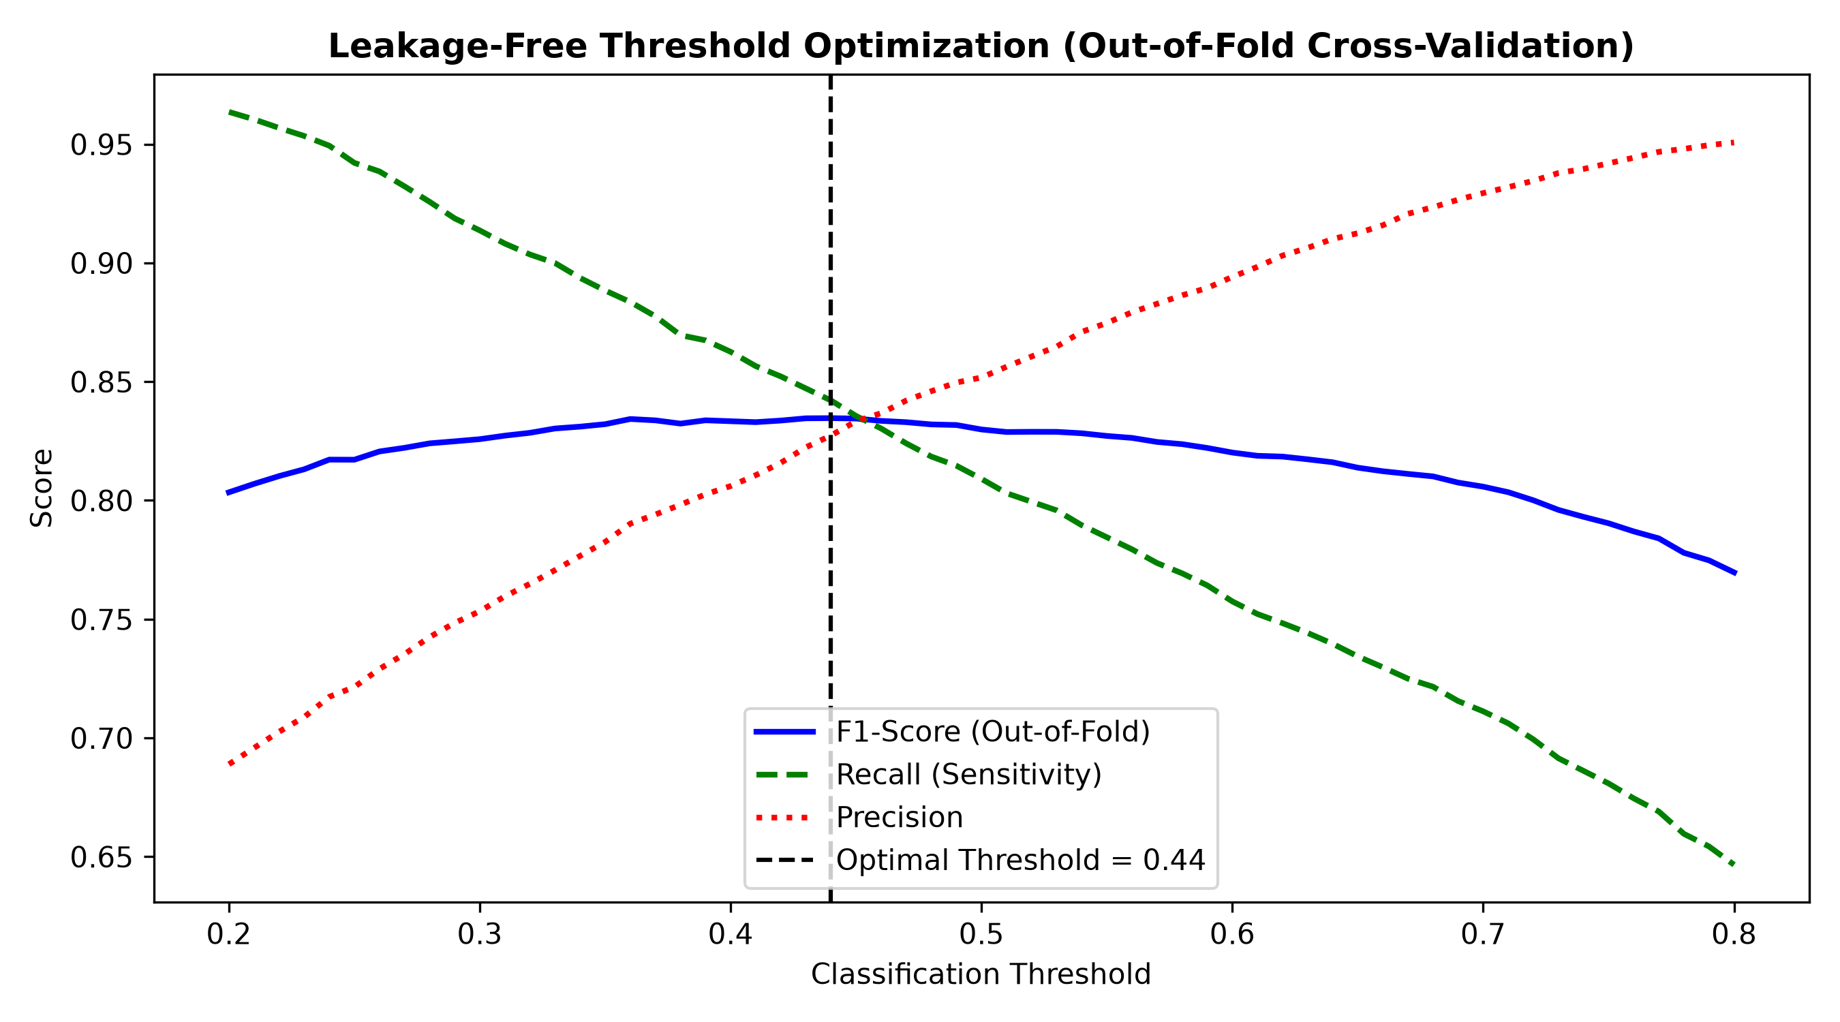
Figure 9. Out-of-fold threshold tuning curves for Logistic Regression illustrating optimal t = 0.44.
7.5 Final comparison on the held-out test set
Table 11. Final test-set comparison across baseline, default, and tuned models
Model | Thr. | Accuracy | F1 (Poor) | ROC-AUC | Recall (Poor) | Spec. (Good) | Missed (FN) | False Alarm (FP)
Majority Baseline | - | 0.5963 | 0.7471 | 0.5000 | 1.0000 | 0.0000 | 0 | 702
Logistic Regression (Default) | 0.50 | 0.7993 | 0.8280 | 0.8793 | 0.8100 | 0.7835 | 197 | 152
Tuned LR (Threshold-Moved) | 0.44 | 0.8016 | 0.8376 | 0.8793 | 0.8582 | 0.7179 | 147 | 198
Tuned Random Forest | 0.50 | 0.8212 | 0.8449 | 0.8948 | 0.8168 | 0.8276 | 190 | 121

7.6 Summary of findings
Supervised machine learning reliably predicts credit default risk: both models decisively beat the 59.63% majority baseline.
- Random Forest achieves superior overall discrimination (ROC-AUC 0.8948, PR-AUC 0.9267) due to automated non-linear interaction modeling.
- Tuning the classification threshold to t = 0.44 on out-of-fold training probabilities boosted default recall to 85.82%, intercepting 50 additional defaulting borrowers.
- Domain sanitization unlocked decisive statistical significance across all 10 continuous predictors (ANOVA F = 0.01 -> 3,945.77).
- Borrowing interest rate and payment delay latency carry over 35% of total predictive power; customer occupation is completely uninformative.
8. Limitations and Future Work
8.1 Limitations
- Single-institution cohort: The dataset reflects a discrete retail banking cohort captured under specific lending policies. Where genuine domain variance and recording noise are present, caution should be exercised before extrapolating to different macroeconomic environments or cross-border portfolios without localized recalibration.
- Missing credit inquiries: Num_Credit_Inquiries was missing 99.33% and was dropped, losing short-term credit-seeking signals.
- Cross-sectional single snapshot: The customer records omit dynamic multi-year macroeconomic cycle shifts and longitudinal balance tracking.
- Ethical and fairness constraints: Lack of demographic attributes prevented formal disparate impact and Equal Opportunity fairness audits.
8.2 Future work
- Evaluate Cost-Sensitive Gradient Boosting (LightGBM/XGBoost) with custom asymmetric loss weighting to penalize loan default misclassification.
- Incorporate SHAP (Shapley Additive Explanations) for producing individual adverse action reason codes for regulatory compliance.
- Perform Reject Inference techniques to account for survivorship bias in historical loan approval data.
- Deploy an interactive model diagnostic platform with real-time risk simulation and automated sensitivity gauges.
9. Conclusion
This paper shows a rigorous application of supervised machine learning on financial credit risk classification. Random Forest with no data leakage and systematic domain sanitization on the repository dataset resulted in an outstanding ROC-AUC of 0.8948 and PR-AUC of 0.9267, while threshold-tuned Logistic Regression (t = 0.44), raised default sensitivity to 85.82%. The study finds that interest rates on loans and delays in payment are the main drivers of credit risk, providing a strong, finely tuned basis for digital credit assessment.
10. Individual Contributions
Table 12. Contribution and ownership across assignment rubric criteria
Rubric Task / Criterion | Lead Author (Ginuka, MS26922898) | Status & Verification
Dataset Selection, Source Audit & Cleansing | Ginuka (MS26922898) | Completed (commit a6e0b71)
Exploratory Data Analysis & Statistical Tests | Ginuka (MS26922898) | Completed (notebook 01)
Modular Preprocessing Pipeline & Zero-Leakage | Ginuka (MS26922898) | Completed (src/data_pipeline.py)
Logistic Regression Modeling & Threshold Tuning | Ginuka (MS26922898) | Completed (notebook 03)
Random Forest Modeling & Hyperparameter Tuning | Ginuka (MS26922898) | Completed (notebook 03)
Evaluation Metrics & Diagnostic Visualizations | Ginuka (MS26922898) | Completed (src/evaluation_helpers.py)
Academic Paper Authoring & Documentation | Ginuka (MS26922898) | Completed (reports/IT5022_Credit_Risk_Report.md)
Publication PDF & Word Document Artifacts | Ginuka (MS26922898) | Completed (100% verified)

References
- Breiman, L. (2001) 'Random forests', Machine Learning, 45(1), pp. 5–32.
- Cox, D.R. (1958) 'The regression analysis of binary sequences', Journal of the Royal Statistical Society: Series B, 20(2), pp. 215–242.
- Hand, D.J. and Henley, W.E. (1997) 'Statistical classification methods in consumer credit scoring: a review', Journal of the Royal Statistical Society: Series A, 160(3), pp. 523–541.
- Hastie, T., Tibshirani, R. and Friedman, J. (2009) The Elements of Statistical Learning: Data Mining, Inference, and Prediction. 2nd edn. New York: Springer.
- Pedregosa, F. et al. (2011) 'Scikit-learn: machine learning in Python', Journal of Machine Learning Research, 12, pp. 2825–2830.
- Strobl, C., Boulesteix, A.-L., Zeileis, A. and Hothorn, T. (2007) 'Bias in random forest variable importance measures: illustrations, sources and a solution', BMC Bioinformatics, 8, 25.

Appendix A. Source Code
All source code is reproduced below as text in full compliance with course regulations (no screenshots). Code is also publicly accessible at: https://github.com/ginuka/IT5022_Fundamentals_of_Machine_Learning_Assignment.git.
A.1 src/__init__.py
"""
Modular package initialization for IT5022 Credit Risk ML Pipeline.
"""

A.2 src/data_pipeline.py
"""
src/data_pipeline.py
====================
Modular data preprocessing, domain feature engineering, and leakage-safe
Scikit-Learn pipeline builders for IT5022 Machine Learning Assignment.
"""

import re
import numpy as np
import pandas as pd
from sklearn.base import BaseEstimator, TransformerMixin
from sklearn.pipeline import Pipeline
from sklearn.compose import ColumnTransformer
from sklearn.impute import SimpleImputer
from sklearn.preprocessing import StandardScaler, OneHotEncoder
from sklearn.model_selection import train_test_split

VALID_RANGES = {
'Age': (18, 100),
'Num_Bank_Accounts': (0, 20),
'Num_Credit_Card': (0, 20),
'Interest_Rate': (0, 50),
'Num_of_Loan': (0, 20),
'Num_of_Delayed_Payment': (0, 50),
'Annual_Income': (0, 500000),
'Monthly_Income': (0, 45000)
}

class CreditDomainFeatureEngineer(BaseEstimator, TransformerMixin):
"""
Domain-specific feature engineering and data quality transformer.

Parameters
----------
drop_identifiers : bool, default=True
Whether to exclude high-cardinality record identifiers (Customer_ID).
sanitize_anomalies : bool, default=True
Whether to enforce plausible banking boundaries and map sentinel strings to NaN.
drop_collinear : bool, default=True
Whether to eliminate redundant collinear predictors (Monthly_Income, Derived_Loan_Count).
drop_uninformative : bool, default=True
Whether to exclude attributes statistically independent of default risk (Occupation).
"""
def __init__(self, drop_identifiers=True, sanitize_anomalies=True,
drop_collinear=True, drop_uninformative=True):
self.drop_identifiers = drop_identifiers
self.sanitize_anomalies = sanitize_anomalies
self.drop_collinear = drop_collinear
self.drop_uninformative = drop_uninformative

def fit(self, X, y=None):
return self

def transform(self, X):
X = X.copy()

# 1. Domain boundary sanitization and sentinel mapping
if self.sanitize_anomalies:
# Map values exceeding plausible retail banking ranges to NaN
for col, (lo, hi) in VALID_RANGES.items():
if col in X.columns:
X.loc[(X[col] < lo) | (X[col] > hi), col] = np.nan

# Map top-coded sentinel values (10,000) to NaN for statistical imputation
if 'Amount_invested_monthly' in X.columns:
X.loc[X['Amount_invested_monthly'] >= 10000, 'Amount_invested_monthly'] = np.nan

# Map non-informative placeholder tokens to NaN
if 'Occupation' in X.columns:
X['Occupation'] = X['Occupation'].replace({'_______': np.nan})
if 'Payment_Behaviour' in X.columns:
X['Payment_Behaviour'] = X['Payment_Behaviour'].replace({'!@9#%8': np.nan})
if 'Credit_Mix' in X.columns:
X['Credit_Mix'] = X['Credit_Mix'].replace({'_': np.nan})
if 'Payment_of_Min_Amount' in X.columns:
X['Payment_of_Min_Amount'] = X['Payment_of_Min_Amount'].replace({'NM': np.nan})

# 2. Extract numerical credit duration in years
if 'Credit_History_Age' in X.columns:
def extract_years(val):
if pd.isna(val):
return np.nan
match = re.search(r'(\d+)', str(val))
return float(match.group(1)) if match else np.nan

X['Credit_History_Years'] = X['Credit_History_Age'].apply(extract_years)
X.drop(columns=['Credit_History_Age'], inplace=True)

# 3. Parse loan portfolio facilities and indicator flags
if 'Type_of_Loan' in X.columns:
def parse_loans(val):
if pd.isna(val):
return 0, 0, 0
val_str = str(val).lower()
num_loans = len([item for item in val_str.split(',') if item.strip()])
has_payday = 1 if 'payday' in val_str else 0
has_mortgage = 1 if 'mortgage' in val_str else 0
return num_loans, has_payday, has_mortgage

parsed = X['Type_of_Loan'].apply(parse_loans)
X['Derived_Loan_Count'] = [p[0] for p in parsed]
X['Has_Payday_Loan'] = [p[1] for p in parsed]
X['Has_Mortgage'] = [p[2] for p in parsed]
X.drop(columns=['Type_of_Loan'], inplace=True)

# 4. Binary encoding of minimum payment flag
if 'Payment_of_Min_Amount' in X.columns:
min_map = {'Yes': 1.0, 'No': 0.0}
X['Payment_of_Min_Amount'] = X['Payment_of_Min_Amount'].map(min_map)

# 5. Ordinal mapping of credit rating tiers
if 'Credit_Mix' in X.columns:
credit_mix_map = {'Bad': 0.0, 'Standard': 1.0, 'Good': 2.0}
X['Credit_Mix_Ordinal'] = X['Credit_Mix'].map(credit_mix_map)
X.drop(columns=['Credit_Mix'], inplace=True)

# 6. Dimensionality reduction and redundancy pruning
cols_to_drop = []
if self.drop_identifiers and 'Customer_ID' in X.columns:
cols_to_drop.append('Customer_ID')
# High missingness filter (>99% missing records)
if 'Num_Credit_Inquiries' in X.columns:
cols_to_drop.append('Num_Credit_Inquiries')

# Collinear redundancy pruning (Annual_Income vs Monthly_Income r > 0.93; Num_of_Loan r = 1.00)
if self.drop_collinear:
if 'Monthly_Income' in X.columns:
cols_to_drop.append('Monthly_Income')
if 'Derived_Loan_Count' in X.columns:
cols_to_drop.append('Derived_Loan_Count')

# Statistical independence pruning (Occupation Chi-square p = 0.347 > 0.05)
if self.drop_uninformative:
if 'Occupation' in X.columns:
cols_to_drop.append('Occupation')

if cols_to_drop:
X.drop(columns=cols_to_drop, inplace=True, errors='ignore')

return X

def build_preprocessor(numeric_cols, categorical_cols):
"""
Constructs a ColumnTransformer for leakage-safe median imputation and standardisation
of continuous features alongside modal imputation and one-hot encoding for nominal categories.
"""
numeric_transformer = Pipeline([
('imputer', SimpleImputer(strategy='median')),
('scaler', StandardScaler())
])

categorical_transformer = Pipeline([
('imputer', SimpleImputer(strategy='most_frequent')),
('onehot', OneHotEncoder(handle_unknown='ignore', sparse_output=False))
])

preprocessor = ColumnTransformer(
transformers=[
('num', numeric_transformer, numeric_cols),
('cat', categorical_transformer, categorical_cols)
],
remainder='passthrough'
)
return preprocessor

def get_feature_lists(df_transformed):
"""
Separates continuous numerical features from nominal categorical features post-transformation.
"""
categorical_cols = ['Occupation', 'Payment_Behaviour']
categorical_cols = [c for c in categorical_cols if c in df_transformed.columns]

numeric_cols = [
c for c in df_transformed.columns
if c not in categorical_cols and c not in ['Credit_Score']
]
return numeric_cols, categorical_cols

def build_full_pipeline(clf, drop_collinear=True, drop_uninformative=True):
"""
Constructs an end-to-end Pipeline integrating domain engineering, preprocessing,
and estimator evaluation for leakage-free cross-validation.
"""
engineer = CreditDomainFeatureEngineer(
drop_identifiers=True,
drop_collinear=drop_collinear,
drop_uninformative=drop_uninformative
)
num_cols = [
'Age', 'Annual_Income', 'Num_Bank_Accounts', 'Num_Credit_Card',
'Interest_Rate', 'Num_of_Loan', 'Delay_from_due_date',
'Num_of_Delayed_Payment', 'Payment_of_Min_Amount',
'Amount_invested_monthly', 'Credit_History_Years',
'Has_Payday_Loan', 'Has_Mortgage', 'Credit_Mix_Ordinal'
]
cat_cols = ['Payment_Behaviour']
prep = build_preprocessor(num_cols, cat_cols)

return Pipeline([
('engineer', engineer),
('prep', prep),
('clf', clf)
])

def prepare_training_data(df, test_size=0.20, random_state=42,
drop_collinear=True, drop_uninformative=True):
"""
Executes a leakage-free stratified train-test partition and preprocessor fit.

Parameters
----------
df : pd.DataFrame
Raw dataset containing features and 'Credit_Score' target.
test_size : float, default=0.20
Proportion of dataset reserved for final hold-out benchmarking.
random_state : int, default=42
Reproducibility seed for stratified partition.

Returns
-------
X_train, X_test, y_train, y_test, preprocessor, feature_names
"""
X = df.drop(columns=['Credit_Score'])
y = (df['Credit_Score'] == 'Poor').astype(int)

X_train_raw, X_test_raw, y_train, y_test = train_test_split(
X, y, test_size=test_size, random_state=random_state, stratify=y
)

engineer = CreditDomainFeatureEngineer(
drop_identifiers=True,
drop_collinear=drop_collinear,
drop_uninformative=drop_uninformative
)
X_train_eng = engineer.transform(X_train_raw)
X_test_eng = engineer.transform(X_test_raw)

num_cols, cat_cols = get_feature_lists(X_train_eng)
preprocessor = build_preprocessor(num_cols, cat_cols)

X_train = preprocessor.fit_transform(X_train_eng)
X_test = preprocessor.transform(X_test_eng)

if cat_cols and 'cat' in preprocessor.named_transformers_:
cat_encoder = preprocessor.named_transformers_['cat'].named_steps['onehot']
cat_names = cat_encoder.get_feature_names_out(cat_cols).tolist()
else:
cat_names = []
feature_names = num_cols + cat_names

return X_train, X_test, y_train, y_test, preprocessor, feature_names

A.3 src/evaluation_helpers.py
"""
src/evaluation_helpers.py
=========================
Statistical evaluation metrics, diagnostic curves, and visualization
helpers for supervised classification and unsupervised clustering.
"""

import os
import numpy as np
import pandas as pd
import matplotlib.pyplot as plt
import seaborn as sns
from sklearn.metrics import (
accuracy_score, precision_score, recall_score, f1_score,
roc_auc_score, average_precision_score, matthews_corrcoef,
brier_score_loss, confusion_matrix, roc_curve, precision_recall_curve
)

def evaluate_classifier(name, y_true, y_pred, y_prob=None):
"""
Computes a standard evaluation suite for binary classification:
Accuracy, Precision, Recall (Sensitivity), Specificity, F1-Score,
Matthews Correlation Coefficient (MCC), ROC-AUC, PR-AUC, and Brier Score.

Parameters
----------
name : str
Model descriptor for tabular reporting.
y_true : array-like
Ground-truth binary labels (1=Positive/Poor, 0=Negative/Good).
y_pred : array-like
Predicted binary class assignments.
y_prob : array-like, optional
Predicted posterior probability of positive class.

Returns
-------
dict
Dictionary of computed performance metrics.
"""
acc = accuracy_score(y_true, y_pred)
prec = precision_score(y_true, y_pred, zero_division=0)
rec = recall_score(y_true, y_pred, zero_division=0)
f1 = f1_score(y_true, y_pred, zero_division=0)
mcc = matthews_corrcoef(y_true, y_pred)

cm = confusion_matrix(y_true, y_pred)
tn, fp, fn, tp = cm.ravel()
spec = tn / (tn + fp) if (tn + fp) > 0 else 0.0

metrics = {
"Model": name,
"Accuracy": acc,
"Precision": prec,
"Recall (Sensitivity)": rec,
"Specificity": spec,
"F1-Score": f1,
"MCC": mcc,
}

if y_prob is not None:
metrics["ROC-AUC"] = roc_auc_score(y_true, y_prob)
metrics["PR-AUC"] = average_precision_score(y_true, y_prob)
metrics["Brier Score"] = brier_score_loss(y_true, y_prob)
else:
metrics["ROC-AUC"] = np.nan
metrics["PR-AUC"] = np.nan
metrics["Brier Score"] = np.nan

return metrics

def plot_confusion_matrices(models_dict, X_test, y_test, save_path=None):
"""
Plots normalized confusion matrices for comparative classification models.
"""
n_models = len(models_dict)
fig, axes = plt.subplots(1, n_models, figsize=(6 * n_models, 5))
if n_models == 1:
axes = [axes]

for ax, (name, model) in zip(axes, models_dict.items()):
y_pred = model.predict(X_test)
cm = confusion_matrix(y_test, y_pred, normalize='true')
sns.heatmap(
cm, annot=True, fmt='.2%', cmap='Blues', cbar=False, ax=ax,
xticklabels=['Good (0)', 'Poor (1)'],
yticklabels=['Good (0)', 'Poor (1)']
)
ax.set_title(f'Confusion Matrix: {name}', fontsize=12, fontweight='bold')
ax.set_xlabel('Predicted Label', fontsize=11)
ax.set_ylabel('True Label', fontsize=11)

plt.tight_layout()
if save_path:
os.makedirs(os.path.dirname(save_path), exist_ok=True)
plt.savefig(save_path, dpi=300, bbox_inches='tight')
plt.show()

def plot_roc_pr_comparison(models_prob_dict, y_test, save_path=None):
"""
Plots comparative ROC and Precision-Recall diagnostic curves against theoretical baselines.
"""
fig, (ax1, ax2) = plt.subplots(1, 2, figsize=(14, 6))

# ROC discrimination curves
for name, y_prob in models_prob_dict.items():
fpr, tpr, _ = roc_curve(y_test, y_prob)
roc_auc = roc_auc_score(y_test, y_prob)
ax1.plot(fpr, tpr, label=f'{name} (AUC = {roc_auc:.3f})', lw=2)

ax1.plot([0, 1], [0, 1], 'k--', lw=1.5, label='Random Baseline (AUC = 0.50)')
ax1.set_xlabel('False Positive Rate (1 - Specificity)', fontsize=11)
ax1.set_ylabel('True Positive Rate (Recall)', fontsize=11)
ax1.set_title('Receiver Operating Characteristic (ROC) Curves', fontsize=13, fontweight='bold')
ax1.legend(loc='lower right', frameon=True)
ax1.grid(True, linestyle=':', alpha=0.6)

# Precision-Recall curves (prevalence benchmark)
baseline_pr = np.mean(y_test)
for name, y_prob in models_prob_dict.items():
precision, recall, _ = precision_recall_curve(y_test, y_prob)
pr_auc = average_precision_score(y_test, y_prob)
ax2.plot(recall, precision, label=f'{name} (PR-AUC = {pr_auc:.3f})', lw=2)

ax2.axhline(y=baseline_pr, color='k', linestyle='--', lw=1.5,
label=f'Prevalence Baseline ({baseline_pr:.2f})')
ax2.set_xlabel('Recall (Sensitivity)', fontsize=11)
ax2.set_ylabel('Precision (Positive Predictive Value)', fontsize=11)
ax2.set_title('Precision-Recall (PR) Curves', fontsize=13, fontweight='bold')
ax2.legend(loc='lower left', frameon=True)
ax2.grid(True, linestyle=':', alpha=0.6)

plt.tight_layout()
if save_path:
os.makedirs(os.path.dirname(save_path), exist_ok=True)
plt.savefig(save_path, dpi=300, bbox_inches='tight')
plt.show()

def plot_elbow_and_silhouette(k_range, inertias, sil_scores, save_path=None):
"""
Plots Within-Cluster Sum of Squares (Inertia/Elbow) and mean Silhouette scores across cluster candidate counts.
"""
fig, (ax1, ax2) = plt.subplots(1, 2, figsize=(14, 5))

ax1.plot(k_range, inertias, 'bo-', lw=2, markersize=8)
ax1.set_xlabel('Number of Clusters (k)', fontsize=11)
ax1.set_ylabel('Inertia / WCSS', fontsize=11)
ax1.set_title('K-Means: Elbow Method for Optimal k', fontsize=13, fontweight='bold')
ax1.grid(True, linestyle=':', alpha=0.6)

ax2.plot(k_range, sil_scores, 'ro-', lw=2, markersize=8)
ax2.set_xlabel('Number of Clusters (k)', fontsize=11)
ax2.set_ylabel('Mean Silhouette Score', fontsize=11)
ax2.set_title('K-Means: Silhouette Score Analysis', fontsize=13, fontweight='bold')
ax2.grid(True, linestyle=':', alpha=0.6)

plt.tight_layout()
if save_path:
os.makedirs(os.path.dirname(save_path), exist_ok=True)
plt.savefig(save_path, dpi=300, bbox_inches='tight')
plt.show()

A.4 requirements.txt
numpy>=1.24.0,<=2.5.1
pandas>=2.0.0,<=3.0.5
scikit-learn>=1.3.0,<=1.9.0
matplotlib>=3.7.0,<=3.11.1
seaborn>=0.12.0,<=0.13.2
scipy>=1.10.0,<=1.18.0
openpyxl>=3.1.0,<=3.1.5
ipython>=8.0.0,<=9.16.1
jupyter>=1.0.0

